**Assignment 3 Example**

**Problem 1: Fill in the information below based on your data which were generated using your ID number as the seed for the random number generator.**

**n = 30 theta = 0.8336096**

**The first 10 approximate 95% confidence intervals are:**

**[,1] [,2]**

**[1,] 0.6999722 0.9666944**

**[2,] 0.6568618 0.9431382**

**[3,] 0.4979767 0.8353566**

**[4,] 0.7926464 1.0073536**

**[5,] 0.6568618 0.9431382**

**[6,] 0.7450226 0.9883107**

**[7,] 0.7926464 1.0073536**

**[8,] 0.6999722 0.9666944**

**[9,] 0.7450226 0.9883107**

**[10,] 0.6153150 0.9180183**

**Do all 10 intervals contain only values between 0 and 1? NO**

**Depending on the value of theta is it possible that some intervals will not contain only values between 0 and 1? Why or why not?**

**Answer is ……**

**The proportion of approximate 95% confidence intervals which contain the true value of theta = 0.8914**

**What factors affect how close this proportion is to 0.95? Under what circumstances might you expect this proportion to be close to 0.95, and under what circumstances would you expect this proportion to be not as close to 0.95?**

**Answer is ….**

**The first ten 15% likelihood intervals (approximate 95% likelihood based confidence intervals) are:**

**[,1] [,2]**

**[1,] 0.6764578 0.9363108**

**[2,] 0.6367535 0.9146738**

**[3,] 0.4903719 0.8159170**

**[4,] 0.7618115 0.9738560**

**[5,] 0.6367535 0.9146738**

**[6,] 0.7179737 0.9562090**

**[7,] 0.7618115 0.9738560**

**[8,] 0.6764578 0.9363108**

**[9,] 0.7179737 0.9562090**

**[10,] 0.5984359 0.8916837**

**Do all 10 likelihood intervals contain only values between 0 and 1? YES**

**Depending on the value of theta is it possible that some likelihood intervals will not contain only values between 0 and 1? Why or why not?**

**Answer is ….**

**The proportion of 15% likelihood intervals which contain the true value of theta = 0.9544**

**What factors affect how close this proportion is to 0.95? Under what circumstances might you expect this proportion to be close to 0.95, and under what circumstances would you expect this proportion to be not as close to 0.95?**

**Answer is ….**

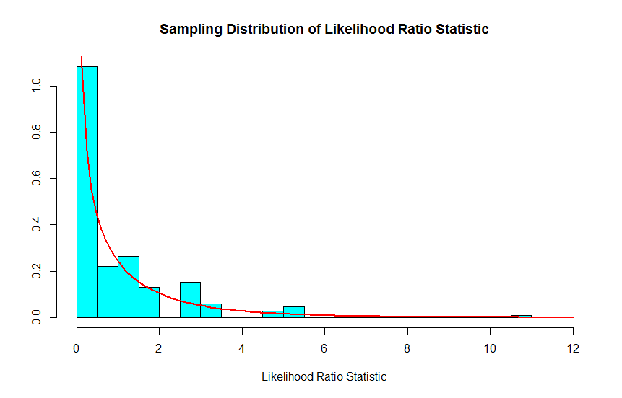

**For Binomial data the likelihood ratio statistic is a discrete or continuous random variable?**

**How well does the Chi-squared(1) probability density function agree with the sampling distribution of the likelihood ratio statistic as approximated by the relative frequency histogram?**

**n = 100 theta = 0.8336096**

**The first 10 approximate 95% confidence intervals are:**

**[,1] [,2]**

**[1,] 0.7446993 0.8953007**

**[2,] 0.8163075 0.9436925**

**[3,] 0.7919905 0.9280095**

**[4,] 0.7563760 0.9036240**

**[5,] 0.7563760 0.9036240**

**[6,] 0.6988077 0.8611923**

**[7,] 0.7331090 0.8868910**

**[8,] 0.8163075 0.9436925**

**[9,] 0.7446993 0.8953007**

**[10,] 0.7331090 0.8868910**

**The proportion of approximate 95% confidence intervals which contain the true value of theta = 0.9436**

**What factors affect how close this proportion is to 0.95? Under what circumstances might you expect this proportion to be close to 0.95, and under what circumstances would you expect this proportion to be not as close to 0.95?**

**Answer is ….**

**The first ten 15% likelihood intervals (approximate 95% likelihood based confidence intervals) to three decimal places are:**

**[,1] [,2]**

**[1,] 0.7376807 0.8863831**

**[2,] 0.8074470 0.9335610**

**[3,] 0.7837396 0.9182707**

**[4,] 0.7490357 0.8944542**

**[5,] 0.7490357 0.8944542**

**[6,] 0.6929403 0.8530908**

**[7,] 0.7263601 0.8781662**

**[8,] 0.8074470 0.9335610**

**[9,] 0.7376807 0.8863831**

**[10,] 0.7263601 0.8781662**

**The proportion of 15% likelihood intervals which contain the true value of theta = 0.9538**

**What factors affect how close this proportion is to 0.95? Under what circumstances might you expect this proportion to be close to 0.95, and under what circumstances would you expect this proportion to be not as close to 0.95?**

**Answer is ….**

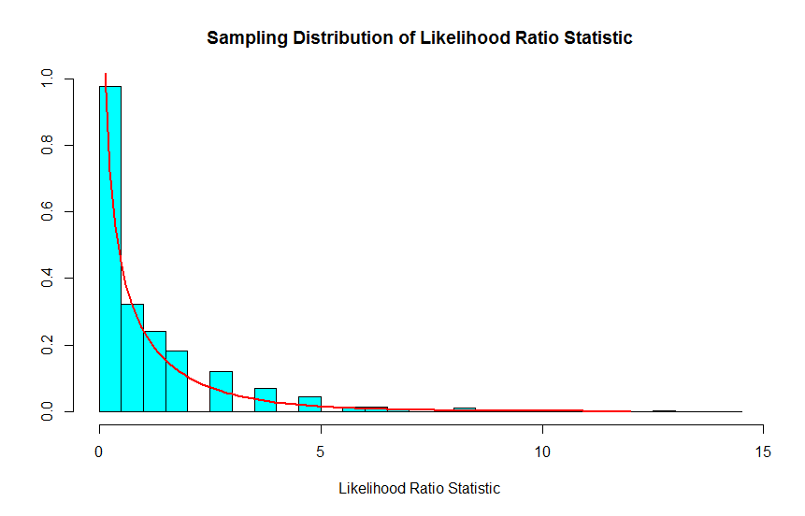

**How well does the Chi-squared(1) probability density function agree with the sampling distribution of the likelihood ratio statistic as approximated by the relative frequency histogram?**

**Answer is ….**

**Compare the graphs for n=30 and n=100.**

**Answer is ….**

**Problem 2: Fill in the information below based on your data which were generated using your ID number as the seed for the random number generator.**

**n = 20 theta = 8**

**The first 10 approximate 95% confidence intervals are:**

**[,1] [,2]**

**[1,] 5.566600 14.252862**

**[2,] 5.280761 13.520992**

**[3,] 2.667126 6.828977**

**[4,] 3.874224 9.919661**

**[5,] 5.992533 15.343433**

**[6,] 3.120172 7.988966**

**[7,] 4.192294 10.734054**

**[8,] 4.614491 11.815057**

**[9,] 4.196023 10.743603**

**[10,] 4.966030 12.715147**

**Do all 10 intervals contain only values greater than 0? YES**

**Depending on the value of theta is it possible that some intervals will not contain only values greater than 0? Why or why not?**

**Answer is ….**

**The proportion of approximate 95% confidence intervals which contain the true value of theta = 0.9246**

**What factors affect how close this proportion is to 0.95? Under what circumstances might you expect this proportion to be close to 0.95, and under what circumstances would you expect this proportion to be not as close to 0.95?**

**Answer is ….**

**The first ten 15% likelihood intervals (approximate 95% likelihood based confidence intervals) are:**

**[,1] [,2]**

**[1,] 6.602221 15.849327**

**[2,] 6.263204 15.035480**

**[3,] 3.163324 7.593868**

**[4,] 4.594993 11.030757**

**[5,] 7.107457 17.062053**

**[6,] 3.700655 8.883794**

**[7,] 4.972236 11.936374**

**[8,] 5.472980 13.138463**

**[9,] 4.976660 11.946993**

**[10,] 5.889920 14.139372**

**Do all your 10 intervals only contain values greater than 0? YES**

**Depending on the value of theta is it possible that some likelihood intervals will not contain only values greater than 0? Why or why not?**

**Answer is ….**

**The proportion of 15% likelihood intervals which contain the true value of theta = 0.9942**

**What factors affect how close this proportion is to 0.95? Under what circumstances might you expect this proportion to be close to 0.95, and under what circumstances would you expect this proportion to be not as close to 0.95?**

**Answer is ….**

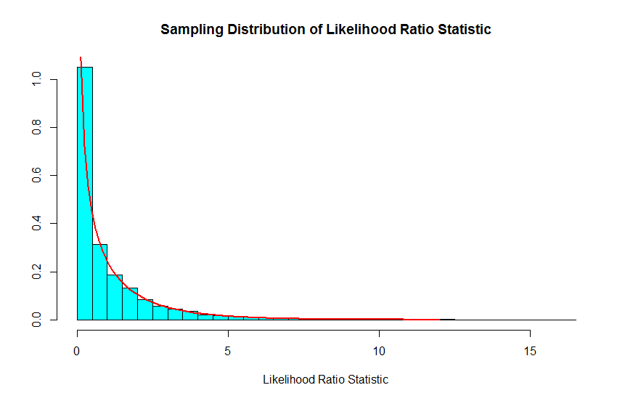

**For Exponential data the likelihood ratio statistic is a discrete or continuous random variable?**

**Answer is ….**

**How well does the Chi-squared(1) probability density function agree with the sampling distribution of the likelihood ratio statistic as approximate by the relative frequency histogram?**

**Answer is ….**

**Problem 3: Fill in the information below based on your data which were generated using your ID number as the seed for the random number generator.**

**mu = 8**

**sigma = 5**

**The first ten 95% confidence intervals for mu are:**

**[,1] [,2]**

**[1,] 6.244030 10.164982**

**[2,] 6.697515 9.783502**

**[3,] 6.212403 9.020471**

**[4,] 4.624907 9.944456**

**[5,] 7.704320 11.294890**

**[6,] 6.578151 11.437126**

**[7,] 5.346232 9.403112**

**[8,] 5.838531 9.540677**

**[9,] 5.704073 9.729931**

**[10,] 5.110502 9.524473**

**The proportion of 95% confidence intervals which contain the true value of mu = 0.9454**

**What factors affect how close this proportion is to 0.95? Under what circumstances might you expect this proportion to be close to 0.95, and under what circumstances would you expect this proportion to be not as close to 0.95?**

**Answer is ….**

**The first ten 95% confidence intervals for sigma are:**

**[,1] [,2]**

**[1,] 3.708505 6.607207**

**[2,] 2.918779 5.200203**

**[3,] 2.655918 4.731881**

**[4,] 5.031321 8.963985**

**[5,] 3.396023 6.050478**

**[6,] 4.595703 8.187871**

**[7,] 3.837067 6.836258**

**[8,] 3.501554 6.238495**

**[9,] 3.807726 6.783983**

**[10,] 4.174810 7.437994**

**The proportion of 95% confidence intervals which contain the true value of sigma = 0.9492**

**What factors affect how close this proportion is to 0.95? Under what circumstances might you expect this proportion to be close to 0.95, and under what circumstances would you expect this proportion to be not as close to 0.95?**

**Answer is ….**

**Problem 4: Fill in the information below based on your data which were generated using your ID number as the seed for the random number generator.**

**model = 1 mu = 8 sigma = 5**

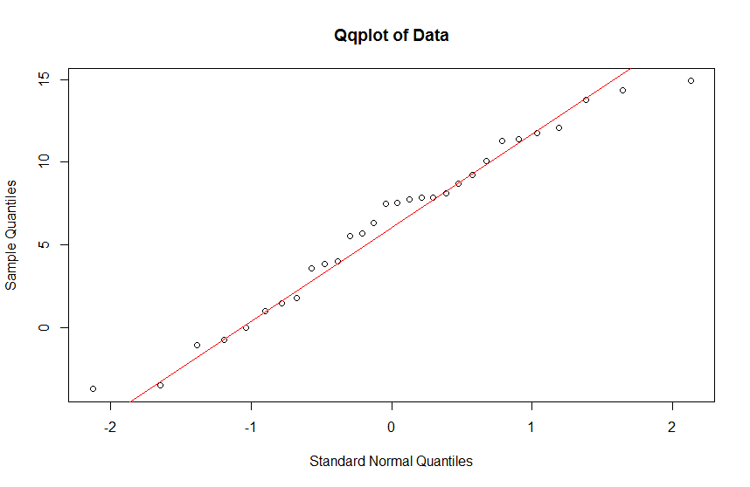

**Based on the qqplot indicate how well the Gaussian model fits the data. Justify your conclusion.**

**mu0 = 9**

> t.test(y,mu=mu0,conf.level=0.95)

One Sample t-test

data: y

t = -2.8669, df = 29, p-value = 0.007643

alternative hypothesis: true mean is not equal to 9

95 percent confidence interval:

4.336738 8.219928

sample estimates:

mean of x

6.278333

**value of test statistic for testing H: mu = mu0 is: -2.8669**

**degrees of freedom of t distribution = 29**

**p-value for testing H: mu=mu0 equals 0.007643**

**95% confidence interval for mu is: [4.336738, 8.219928]**

**Insert your conclusion regarding H: mu=mu0 here.**

**sample mean = 6.278333**

**sigma0 = 7**

**sample variance = 27.03675**

**p-value for testing H: sigma = sigma0 equals 0.04895834**

**Insert your conclusion regarding H: sigma=sigma0 here.**

**95% confidence interval for sigma squared: [17.14843, 48.86035]**

**95% confidence interval for sigma: [4.141067, 6.990018]**

**Problem 5: Fill in the information below based on your data which were generated using your ID number as the seed for the random number generator.**

**alpha = 2.293382 beta = -2.601833 model = 1**

**sample correlation = -0.8625526**

Call:

lm(formula = y ~ x)

Residuals:

Min 1Q Median 3Q Max

-21.2398 -5.9288 -0.4623 7.0616 20.0681

Coefficients:

Estimate Std. Error t value Pr(>|t|)

(Intercept) 5.435 2.021 2.69 0.0084 **

x -2.954 0.175 -16.88 <2e-16 ***

---

Signif. codes: 0 ‘***’ 0.001 ‘**’ 0.01 ‘*’ 0.05 ‘.’ 0.1 ‘ ’ 1

Residual standard error: 9.326 on 98 degrees of freedom

Multiple R-squared: 0.744, Adjusted R-squared: 0.7414

F-statistic: 284.8 on 1 and 98 DF, p-value: < 2.2e-16

**estimate of the intercept = 5.435**

**estimate of the slope = -2.954**

**degrees of freedom of t distribution = 98**

**value of test statistic for testing H: no relationship (slope = 0) equals -16.88**

**p-value for testing the H: no relationship (slope = 0) equals 2e-16**

**Insert your conclusion regarding the hypothesis of no relationship here.**

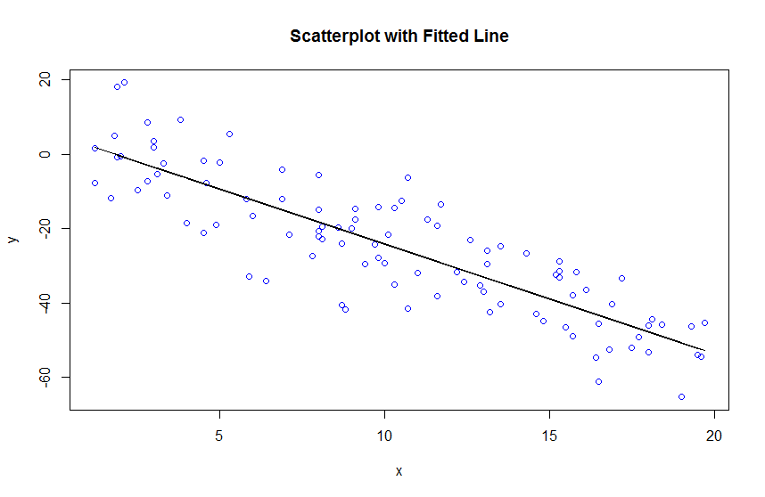

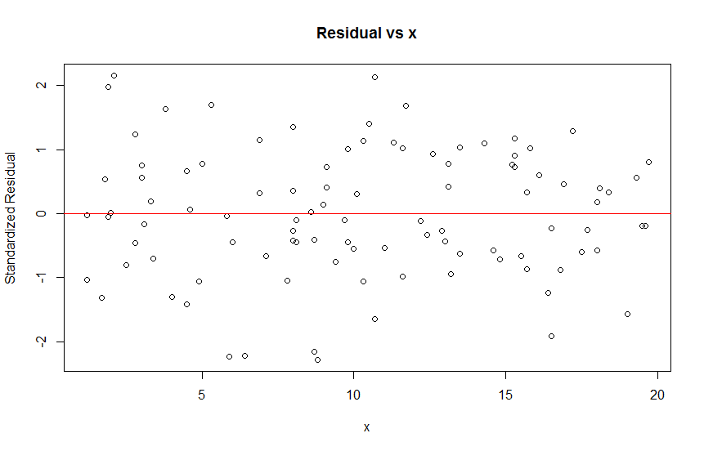

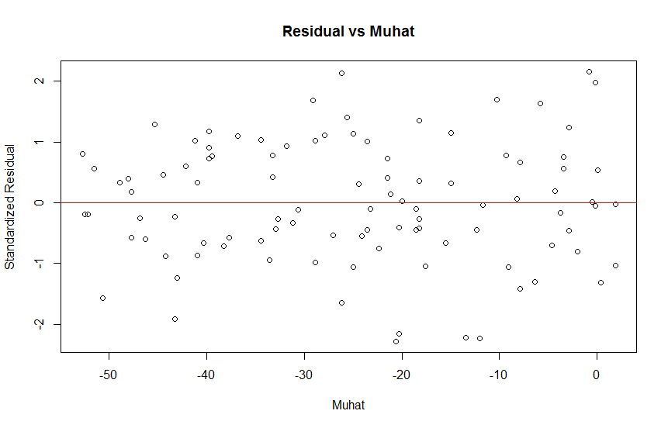

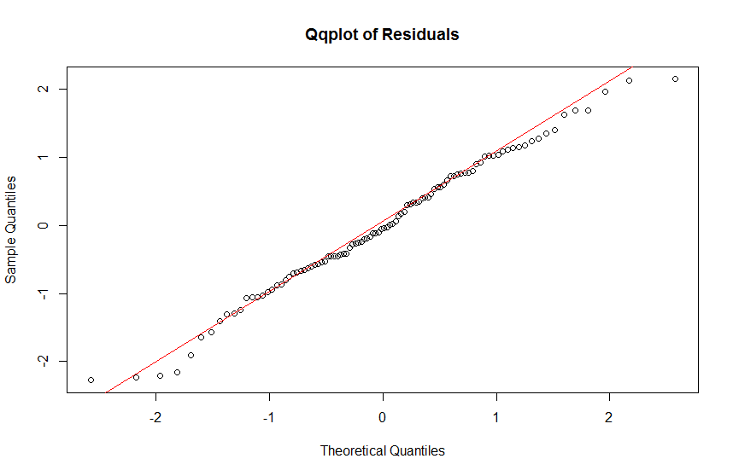

**Based on the scatterplot with fitted line and the residual plots discuss the fit of the simple linear model to your data. Be sure to comment on each plot. Indicate clearly what you expect to see for each plot if the model assumptions hold and what you observe for your data.**

**Estimate of the slope: -2.954**

**95% confidence interval for the slope:**

**[-3.301399, -2.606673]**

**Estimate of mean response at x=5: -9.334851**

**90% confidence interval for the mean response at x=5:**

**[-11.507 -7.162702]**

**Estimate of predicted response at x=2: -0.4727425**

**99% prediction interval for the response at x=2:**

**[-25.38452, 24.43904]**

**Estimate of sigma: 9.326**

**95% confidence interval for the sigma:**

**[8.183567, 10.84312]**